**Include JFrog entries in VS**

If we have an old entry in VS and we need to update it as your VS, otherwise your VS projects will not build.

Please update the JFrog in VS.

1. Go to Visual Studio -> Tools-> Options-> NuGet Package Manager-> Package source and remove existing JFrog entries and add below two entries.

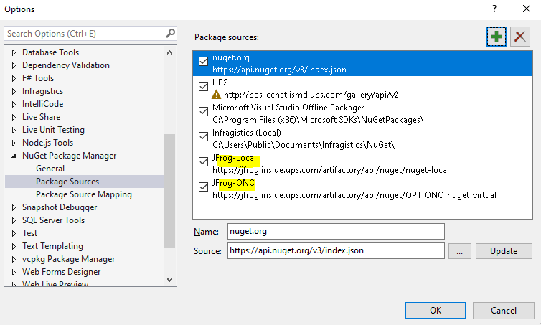

JFrog-ONC

<https://jfrog.inside.ups.com/artifactory/api/nuget/OPT_ONC_nuget_virtual>

                JFrog-Local

<https://jfrog.inside.ups.com/artifactory/api/nuget/nuget-local>

1. Login to JFrog account

<https://artifactoryrr.inside.ups.com/ui/login/>

Open above URL and login with SAML SSO option with your ups GD ID and Password (The same we are using for ITAS)

e.g., [GD123@ups.com](mailto:GD123@ups.com) and your password

1. Go to edit profile and generate an identity token by putting any description.

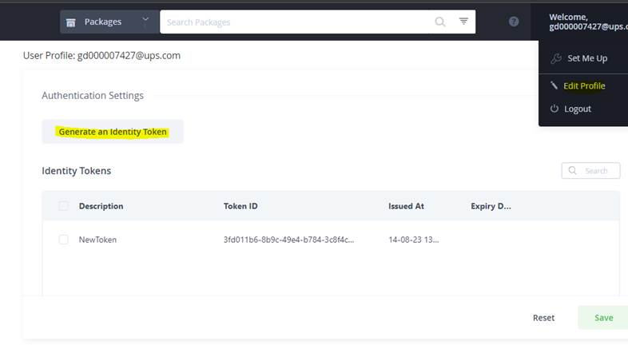

1. Copy the token somewhere like in OneNote / Notepad++ etc. for future reference as this would be your password.

*Note: Do the step 5 only if it is applicable, if Jfrog entries are not available and you can skip this.*

1. Go to Control Panel-> User Account-> Credential Manager -> Windows Credentials and remove first JFrog entry only if it is available.

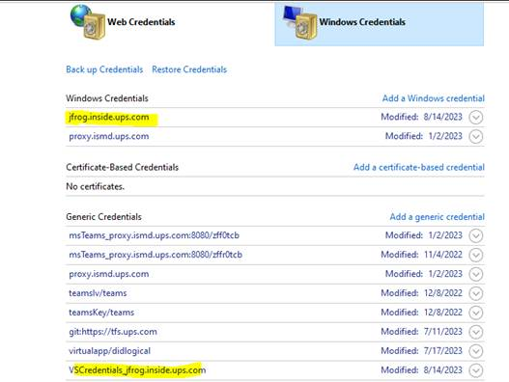

And open the VSCredentials_jfrog.inside.ups.com and update the password with your generated token.

Note: Put your GDID as your ID i.e., [GD123@ups.com](mailto:GD123@ups.com)

1. Close all the instances of VS and open in **admin mode** only and take the latest and clean it.
2. Right Click on solution and go to NuGet Package Manager and restore it.

*Note: Make sure you can see packages available in Local and ONC by switching them.*